Task 1: Network Topology Diagram with IP Addressing

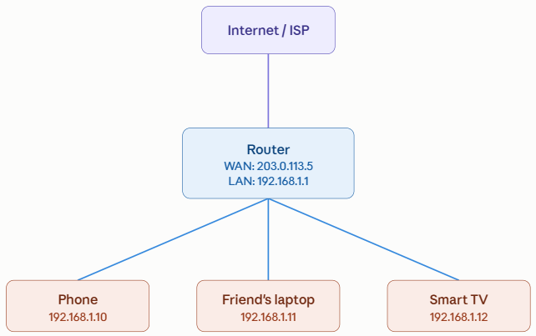

Task 2: Step-by-Step Inter-Subnet Packet Forwarding & Routing Simulation

Scenario (made-up IPs):
- My laptop: 192.168.1.10/24, gateway 192.168.1.1 (Router A)
- Friend's computer: 192.168.2.20/24, gateway 192.168.2.1 (Router B)
- Router A and Router B are linked via a point-to-point network: Router A = 10.0.0.1/30, Router B = 10.0.0.2/30
Step-by-step:
- My laptop checks the destination. 192.168.2.20 isn't in its own subnet (192.168.1.0/24), so it can't deliver directly — it sends the packet to its default gateway, Router A.
- Router A checks its routing table: 192.168.1.0/24 → directly connected (LAN interface)
192.168.2.0/24 → next hop 10.0.0.2 (WAN interface)
It matches 192.168.2.0/24 and forwards the packet out toward Router B.
- Router B receives the packet on its 10.0.0.2 interface and checks its own table:
192.168.2.0/24 → directly connected (LAN interface)
192.168.1.0/24 → next hop 10.0.0.1 (WAN interface)
Since 192.168.2.0/24 is directly connected, it forwards the packet onto that LAN.
- The packet reaches the friend's computer — now on the correct local subnet, delivery happens directly (via ARP/MAC lookup).
- The reply follows the same path in reverse: friend's computer → Router B → Router A → my laptop.

Task 3: Routing table — Zomato-style delivery network (3 city branches)

Destination Network | Subnet Mask | Next Hop | Interface
10.1.0.0 (Mumbai branch) | 255.255.255.0 | 172.16.0.2 | WAN1
10.2.0.0 (Delhi branch) | 255.255.255.0 | 172.16.0.6 | WAN2
10.3.0.0 (Bangalore branch) | 255.255.255.0 | 172.16.0.10 | WAN3

Task 4: Static vs dynamic routing

Static Routing:
- Pros:
- Zero CPU and memory overhead on network hardware (no routing protocol calculations).
- Zero bandwidth consumption (no hello packets or routing table advertisements sent across links).
- Highly secure, as administrators strictly control exactly which paths data can traverse.
- Cons:
- High manual administrative overhead as network scale increases.
- No automatic failover—if a leased line drops, traffic cannot reroute unless manually edited.
- High risk of human configuration error and routing loops in large environments.
- App Example: A dedicated, unchanging IPsec VPN tunnel between a local bank branch and an payment gateway endpoint like Paytm Gateway, where paths must remain rigid, unadvertised, and predictable.
Dynamic Routing Protocols (OSPF / RIP):
- Pros:
- Automatic topology discovery and real-time route calculation.
- Dynamic rerouting around failed links or congested nodes without manual human intervention.
- High scalability when expanding into hundreds of regional fulfillment hubs.
- Cons:
- Consumes device compute resources (CPU/RAM) to calculate shortest-path tree algorithms (e.g., Dijkstra).
- Sends background network traffic (link-state advertisements, hello heartbeats).
- More complex to troubleshoot and configure securely (e.g., neighbor authentication, area design).
- App Example: Zomato / Swiggy backend services hosted across multiple cloud regions and availability zones. If a fiber link drops between Mumbai and Bengaluru during peak evening dinner rush, dynamic routing instantly detects link loss and recalculates alternative paths through Hyderabad without dropping customer orders or delivery partner telemetry.

Task 5: OSPF Configuration Between Two Routers (AI-generated)

AI-Generated Cisco IOS Configuration Snippet:

Router 1 Configuration: Router1(config)# router ospf 1
Router1(config-router)# router-id 1.1.1.1
Router1(config-router)# network 10.0.1.0 0.0.0.255 area 0
Router1(config-router)# network 172.16.1.0 0.0.0.3 area 0
Router1(config-router)# exit
Router 2 Configuration: Router2(config)# router ospf 1
Router2(config-router)# router-id 2.2.2.2
Router2(config-router)# network 10.0.2.0 0.0.0.255 area 0
Router2(config-router)# network 172.16.1.0 0.0.0.3 area 0
Router2(config-router)# exit
Line-by-Line Explanation:
- router ospf 1: Initializes the OSPF routing process in configuration mode. The number 1 is a local Process ID used by the router operating system to track this routing instance.
- router-id 1.1.1.1 (and 2.2.2.2): Manually assigns a unique 32-bit identifier to each router in the OSPF autonomous system. This ID is used for tie-breaking during Designated Router (DR) elections and tracking link-state advertisements (LSAs).
- network 10.0.1.0 0.0.0.255 area 0: Identifies which local interfaces participate in OSPF.
  - 10.0.1.0: The network address of the connected LAN.
  - 0.0.0.255: The wildcard mask (inverse of 255.255.255.0), telling the router to match all IP addresses where the first 24 bits match 10.0.1.*.
  - area 0: Places this network into OSPF Area 0 (the standard OSPF backbone area).
- network 172.16.1.0 0.0.0.3 area 0: Enables OSPF on the point-to-point link connecting the two routers (/30 mask corresponds to wildcard 0.0.0.3). This allows R1 and R2 to discover each other, exchange Hello packets, become adjacent neighbors, and synchronize their link-state databases.
- exit: Saves the current command context and returns to global configuration mode.

